Mrs. Claus’ Closet November 20, 2008
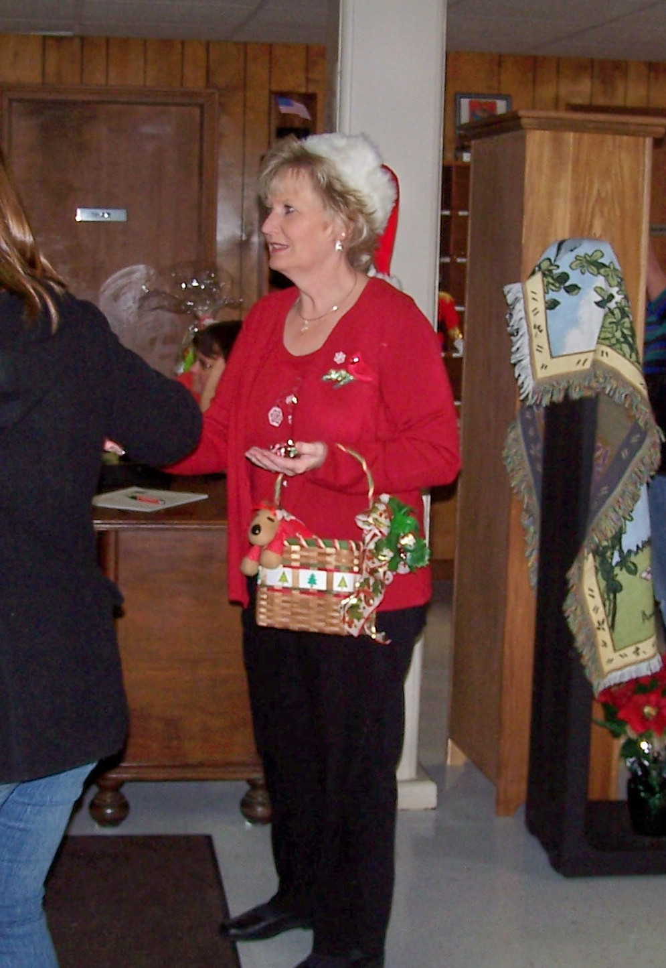
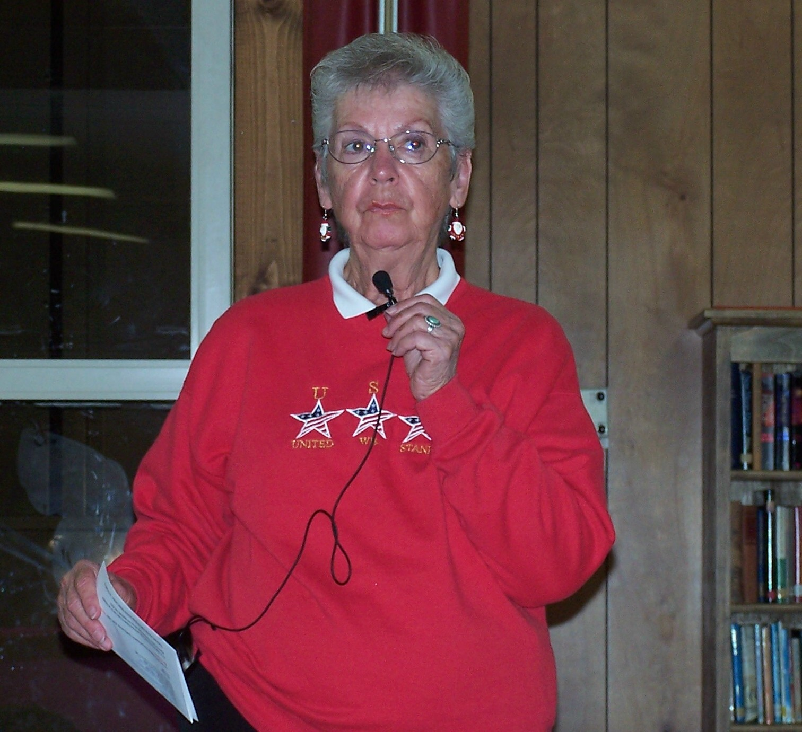
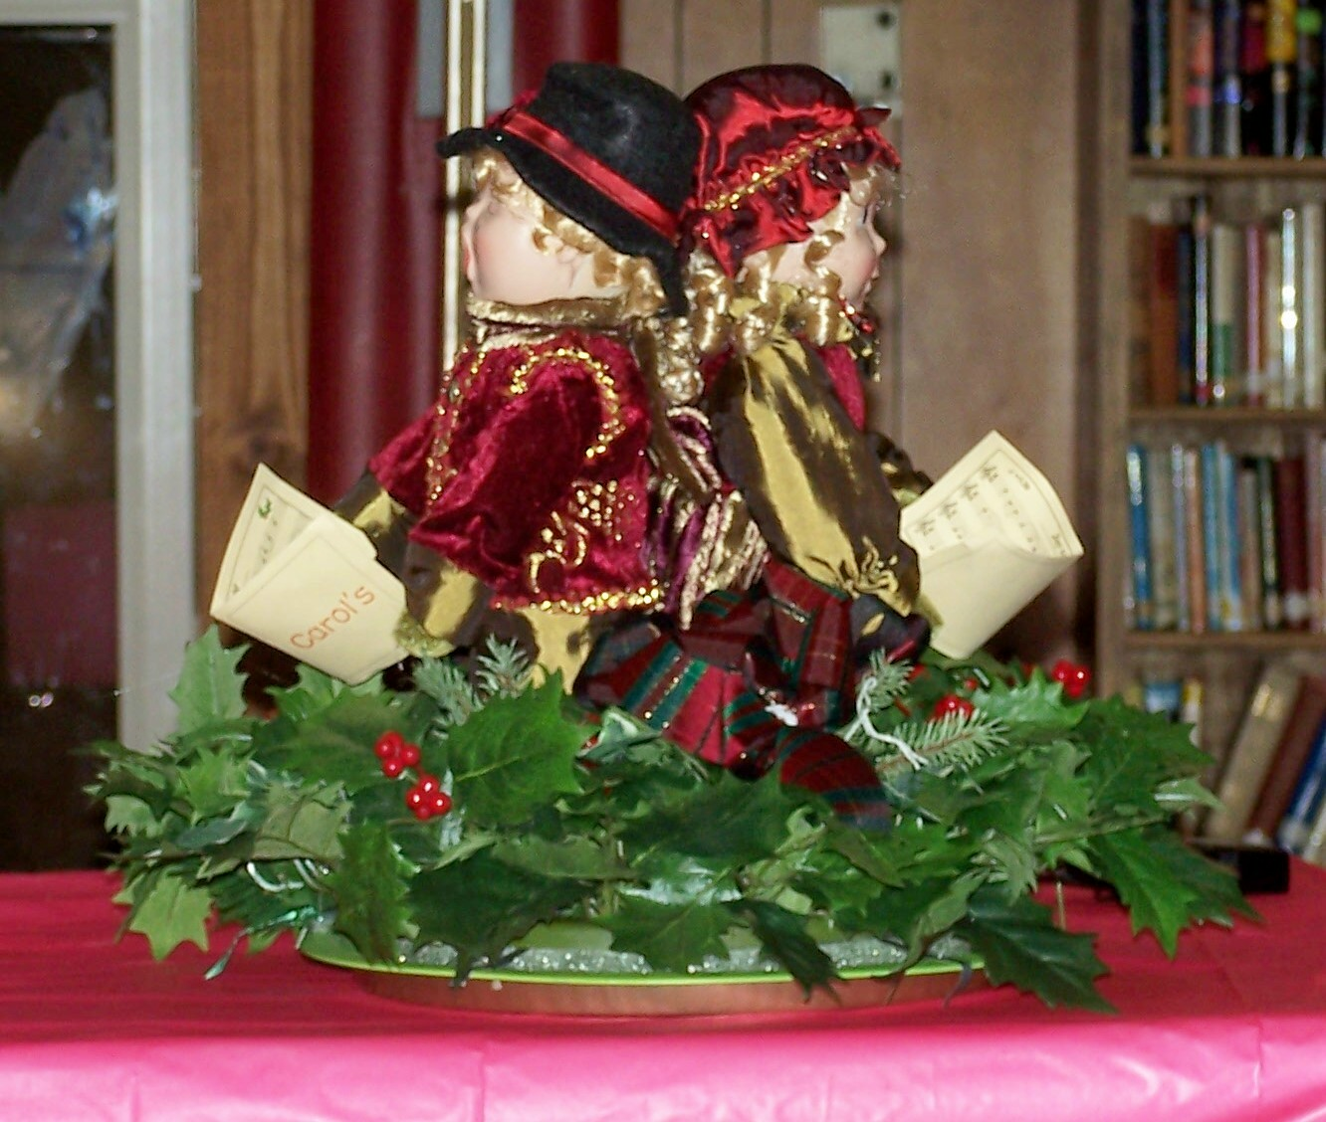
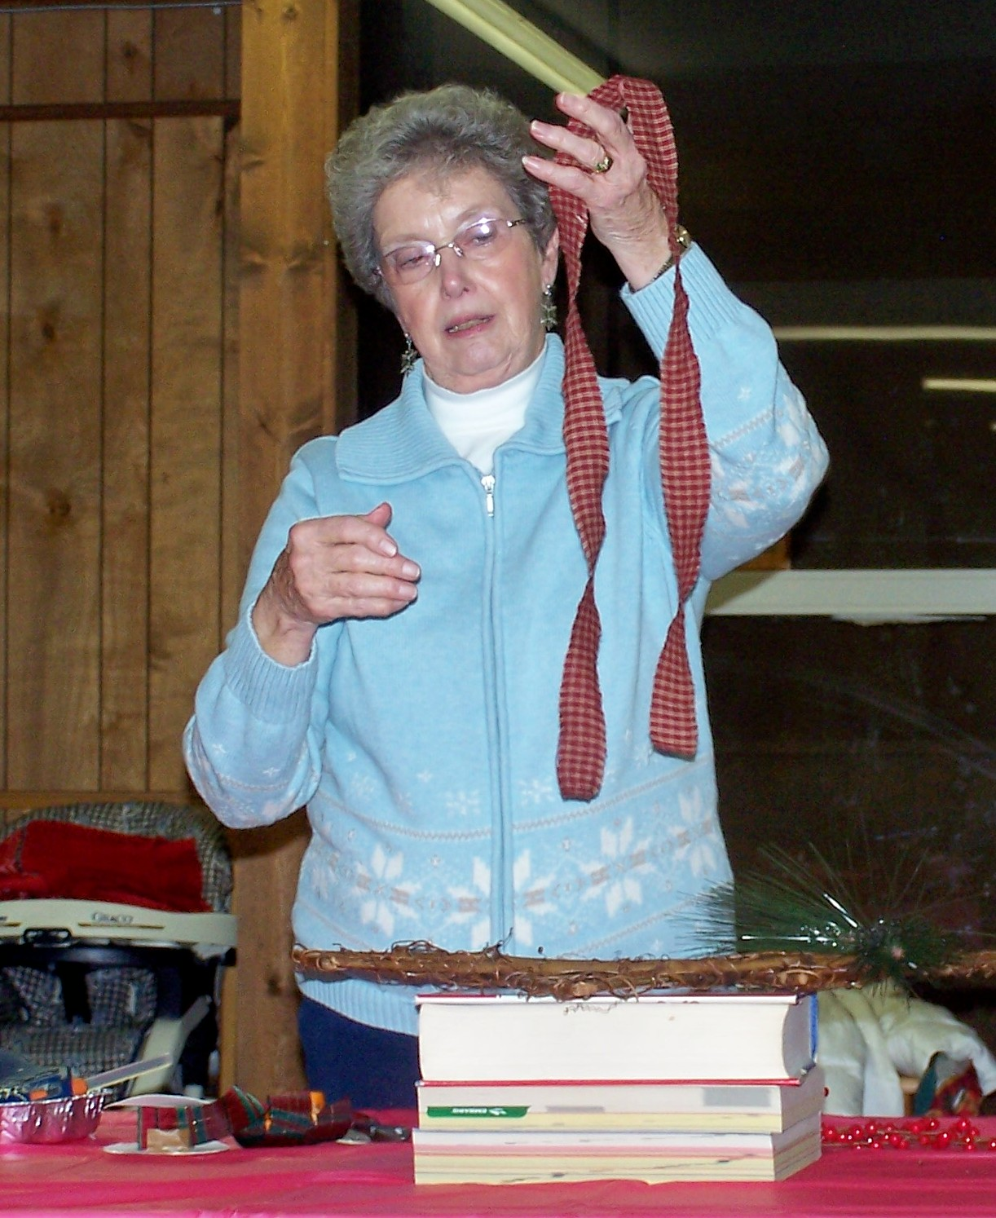
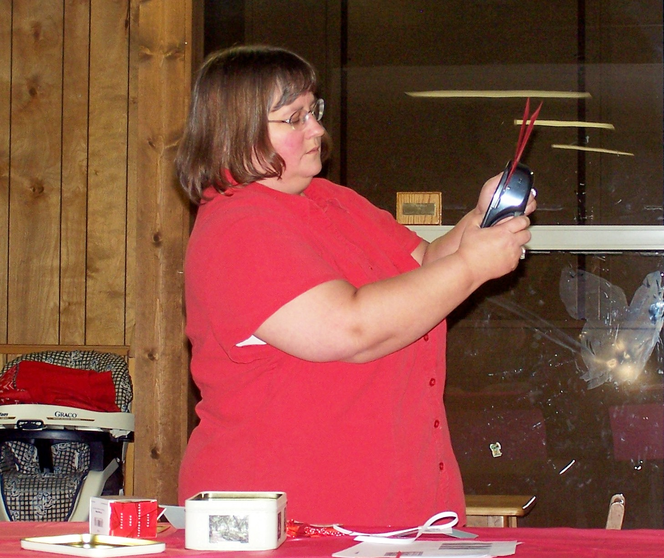
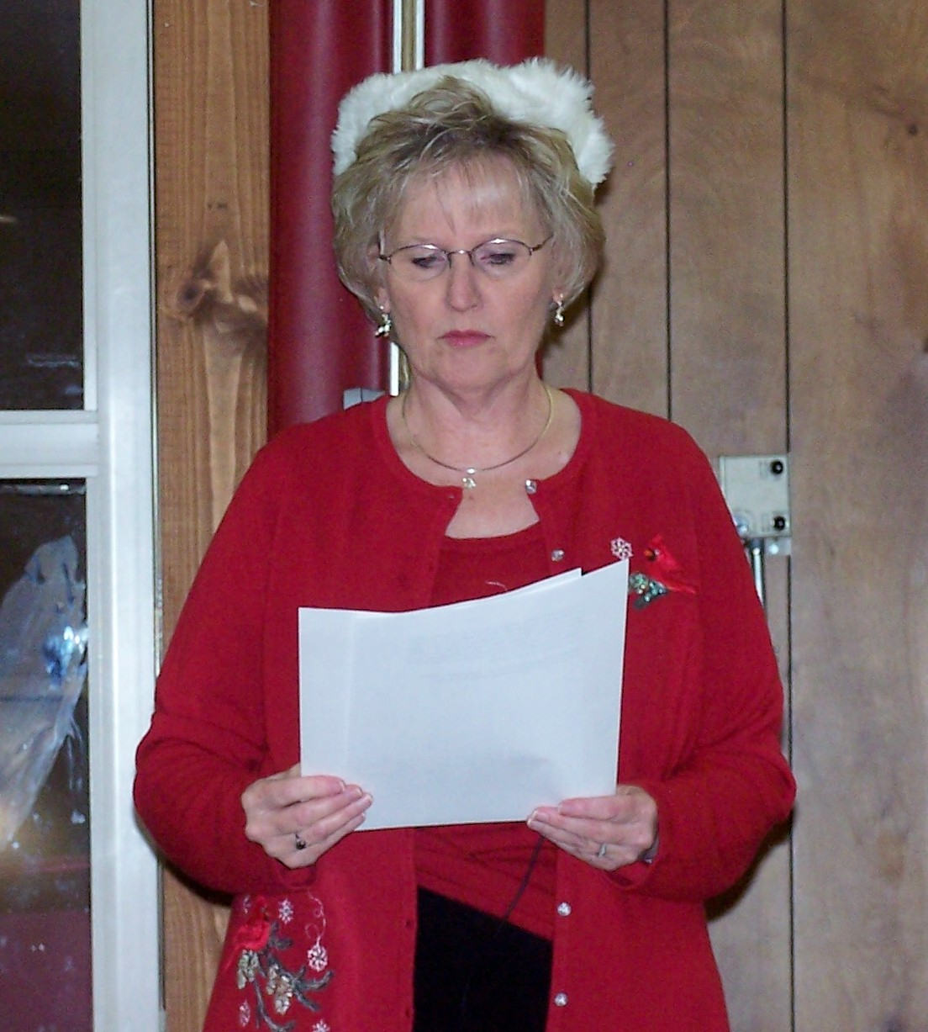
Mrs. Claus’ Closet was held during the first snow of the season, so turnout was not up to par. Those that attended were greeted by Dorothy Cleer who welcomed each person as she handed out candy. There were several tables set up with items that had been donated for the silent auction. Carol Jean Goddard was once again “Mistress” of Ceremony and introduced each of the demonstrators. The first demonstrator was Louise List who braved the snow covered roads coming from Cortland. Louise demonstrated how to make a Caroling centerpiece and also an easy decoration using a vine Christmas tree and by just adding a few embellishments, you have a lovely wall hanging or door decoration. After her demonstrations Louise headed for home. Next Kim Stevens demonstrated how to make a gift card holder, a tic tac snowman holder and also a candy bar holder. Renee Stevens demonstrated how to make an easy winter scarf.

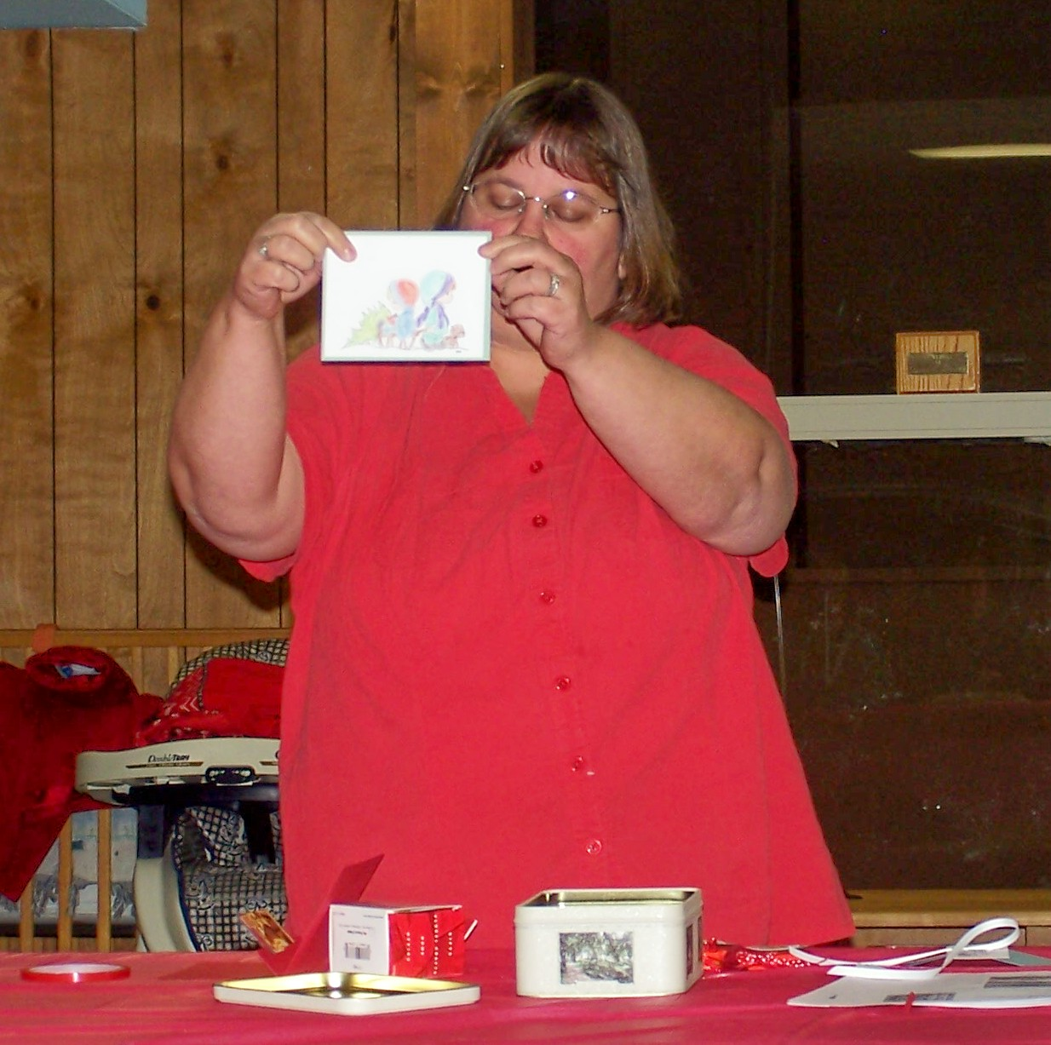

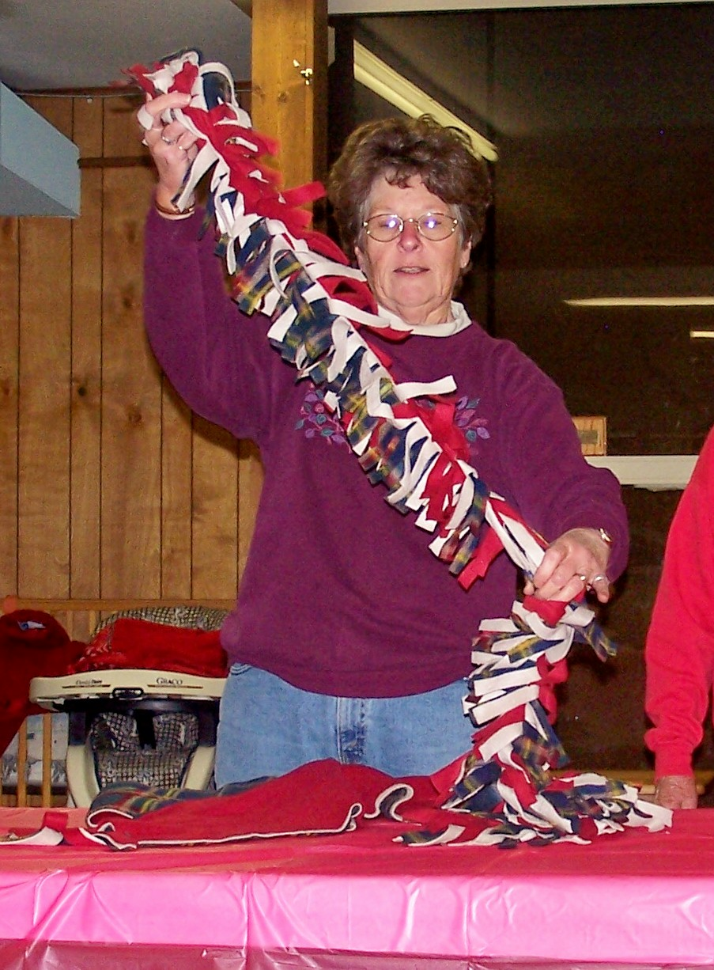
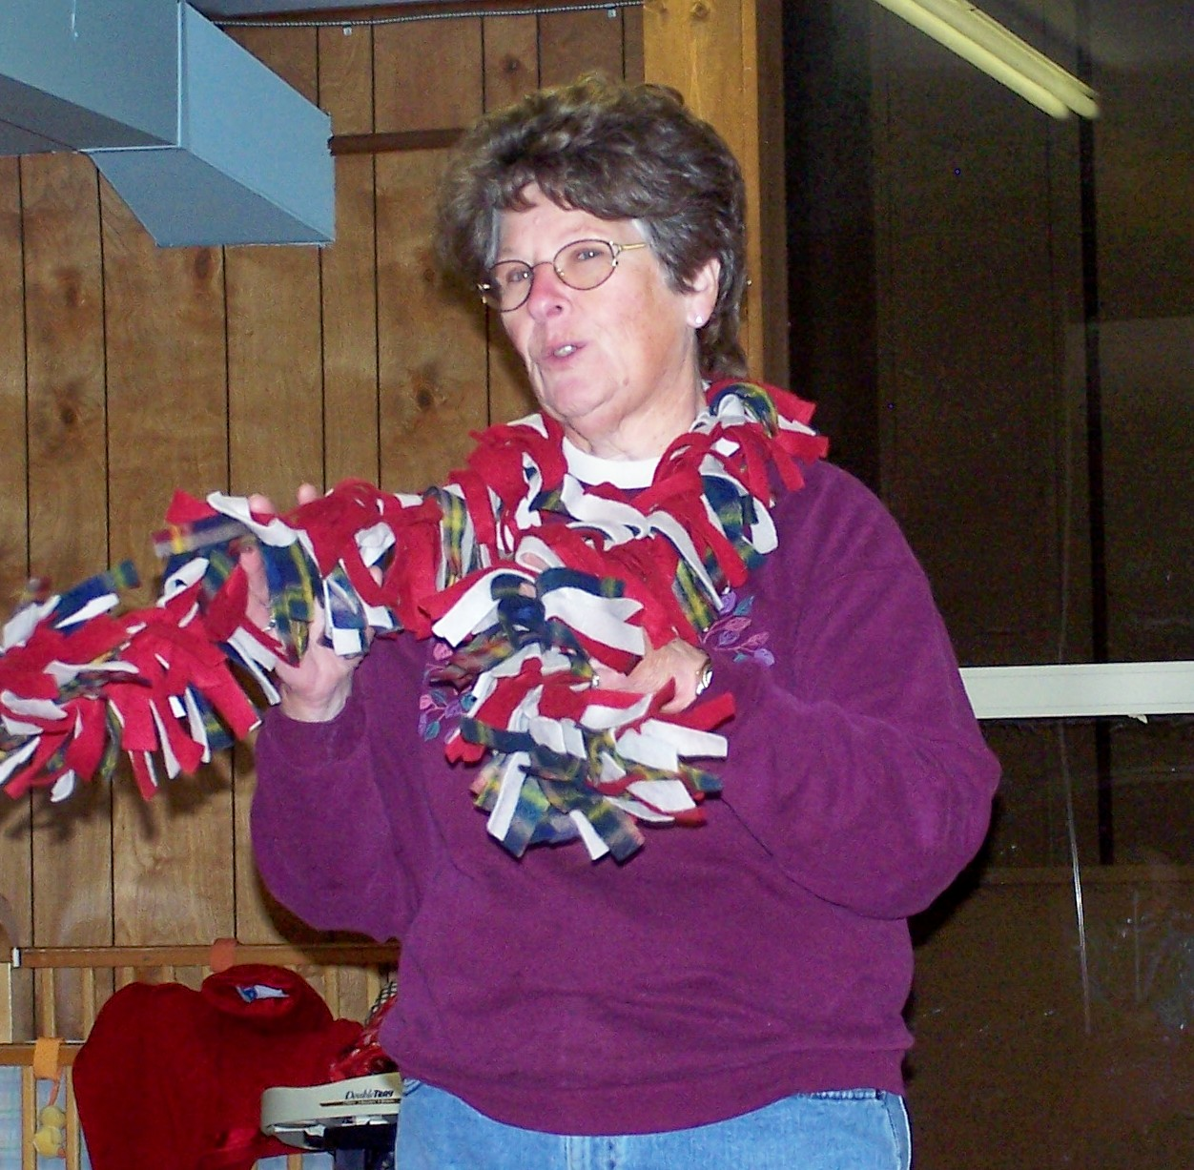
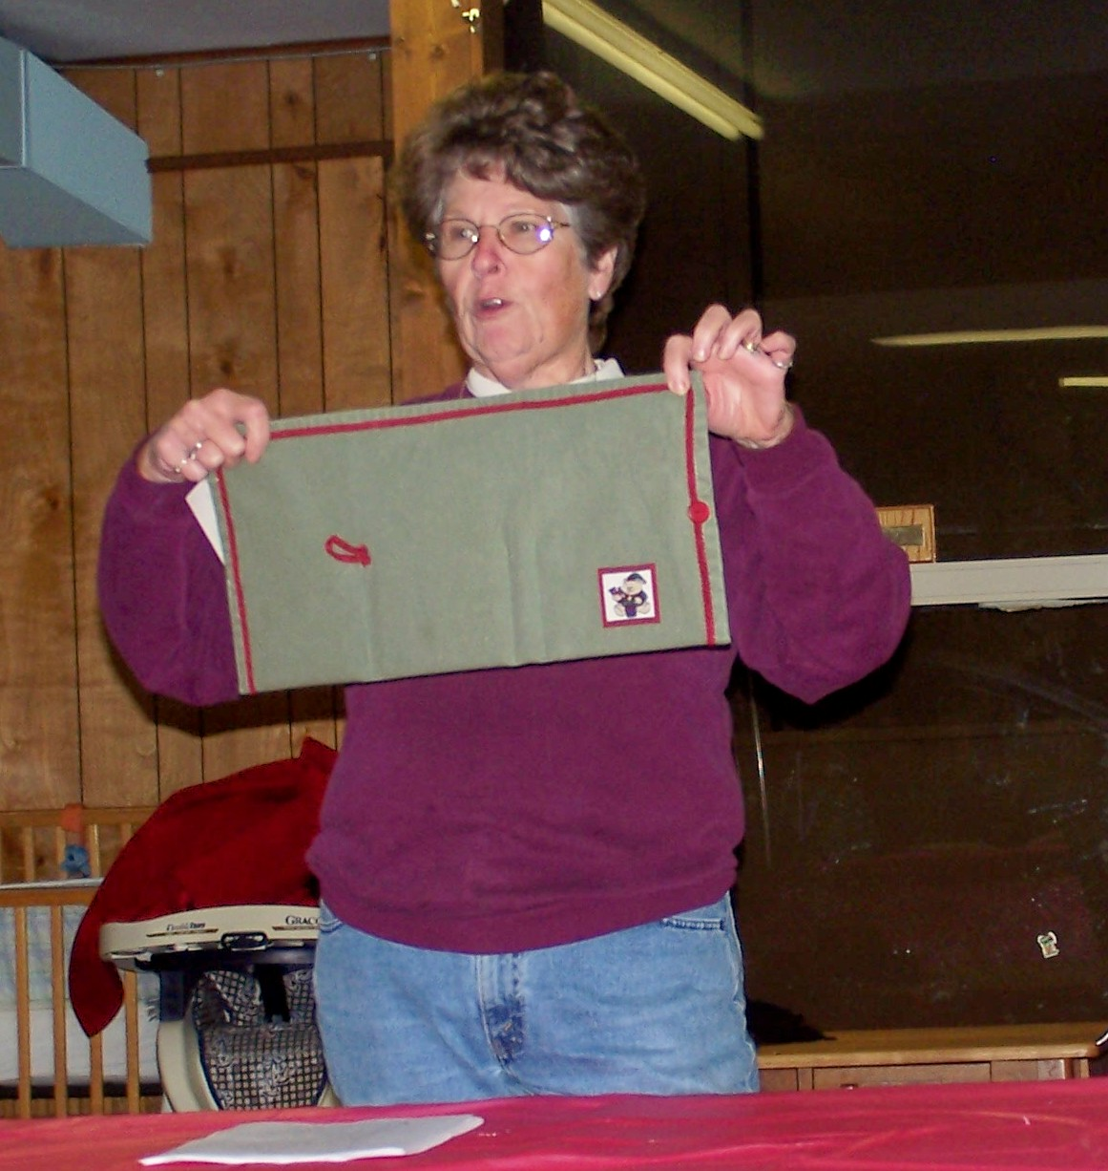
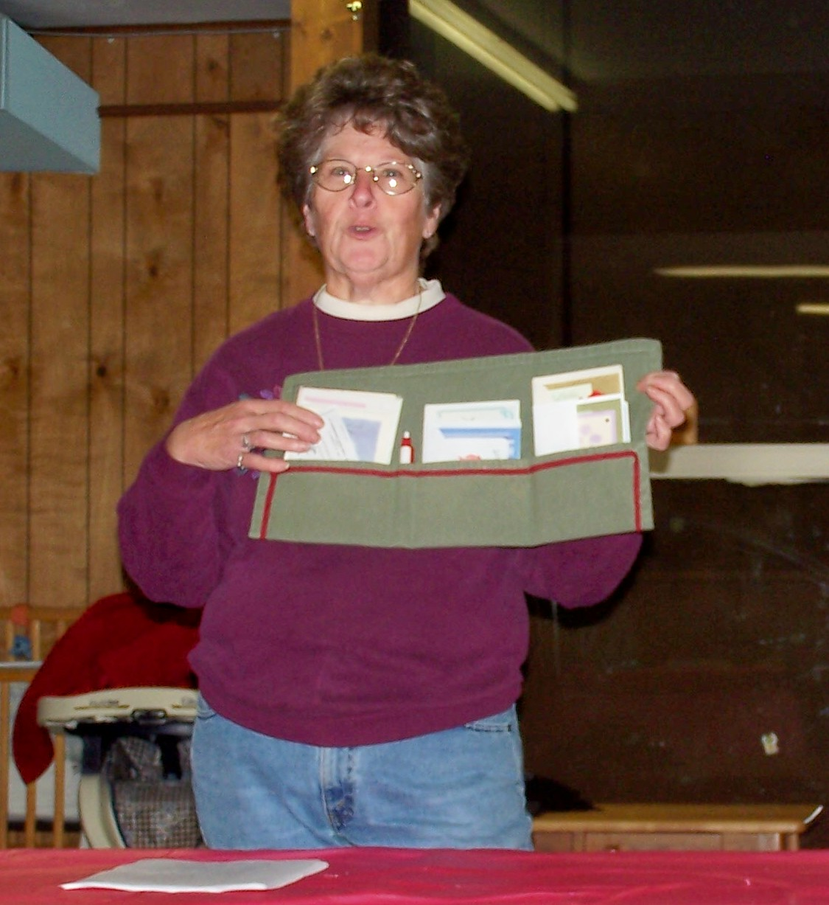
Dorothy Cleer aka Mrs. Claus, read some interesting facts on the Christmas tree. There was a brief intermission for some wonderfully prepared food and dessert and putting in bids on the silent auction. Renee Stevens also demonstrated how to make a folder for cards, supplies, etc. using a place mat. Our last demonstrator of the evening was Kelly Odegard demonstrated how to make a ribbon bow. We were all given pieces of ribbon while she was instructing us. Some of us (especially me) were all thumbs and no matter how hard we tried, could not get the hang of it. All in all it was a fun filled evening with great food, fellowship and different ideas for Christmas gifts. Thanks to the UMW for all their hard work in bringing this together. If you missed out this year – we hope to see you next year.


