THE SHEPHERD AND HIS WIFE
On Sunday, December 23 the Sunday School Children held the Christmas Pageant during services.
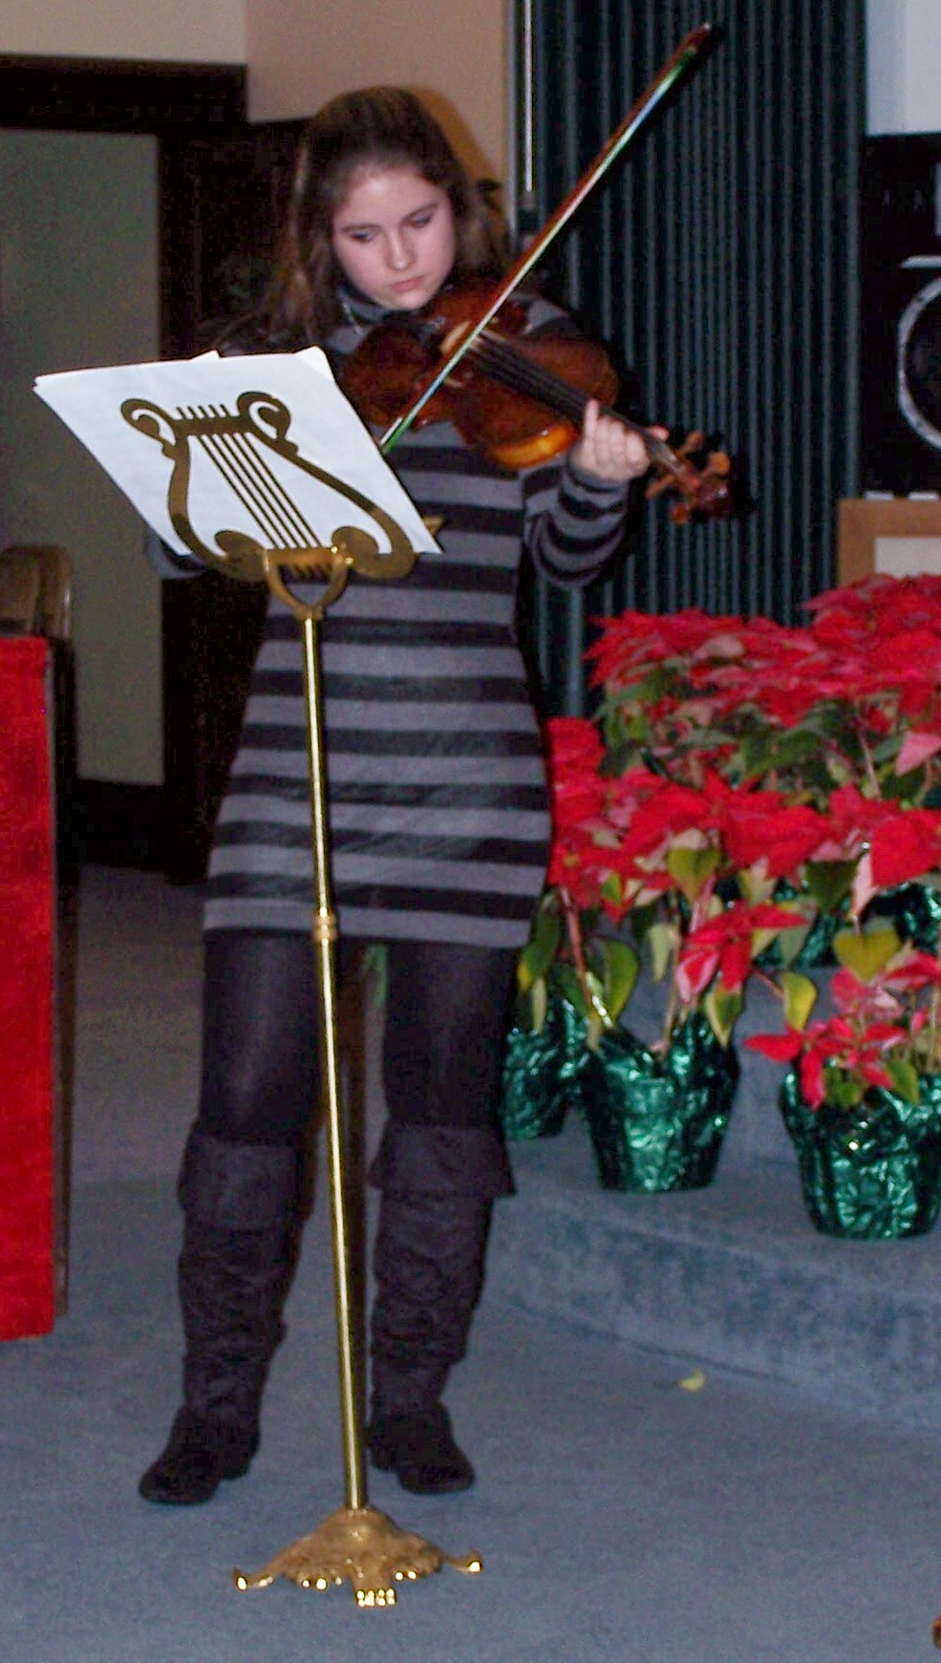
The cast was:

Violinist: Jesse Jones
Main Shepherd: Brandy Burbach
Sheperd's Wife: Laura Davis
Mary: Jesstyn Crites
Joseph: Justin Oliver
Shepherd: Ethan Davenport
Three Kings: Christopher Crites, Steve Burbach, Sheyanne Stauffer
Angels: Madee McDowell, Briana McDowell, Lexi Swiger
Narrator: Dorothy Cleer
Helpers: Milly Largen, Sue Davis, Denise McDowell, and Judy Karr
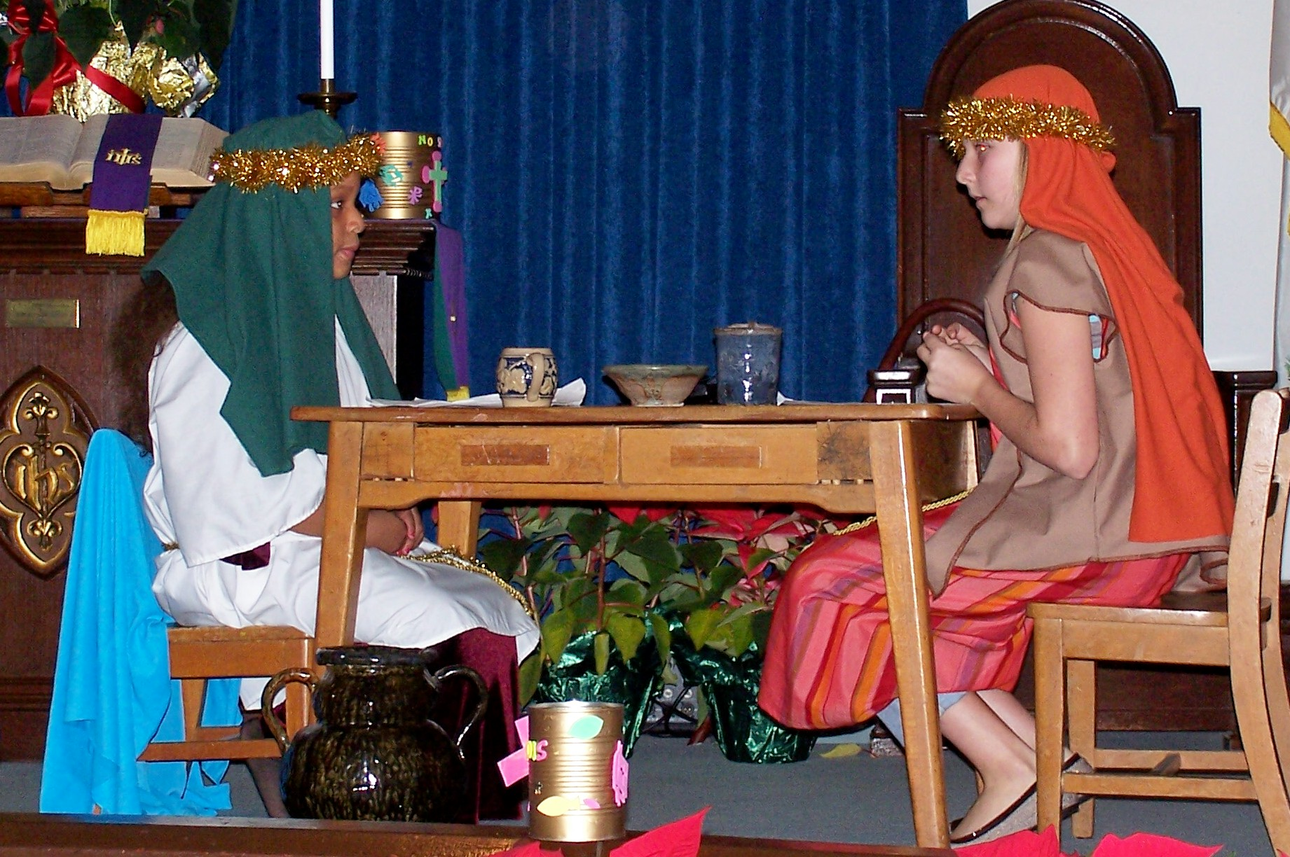
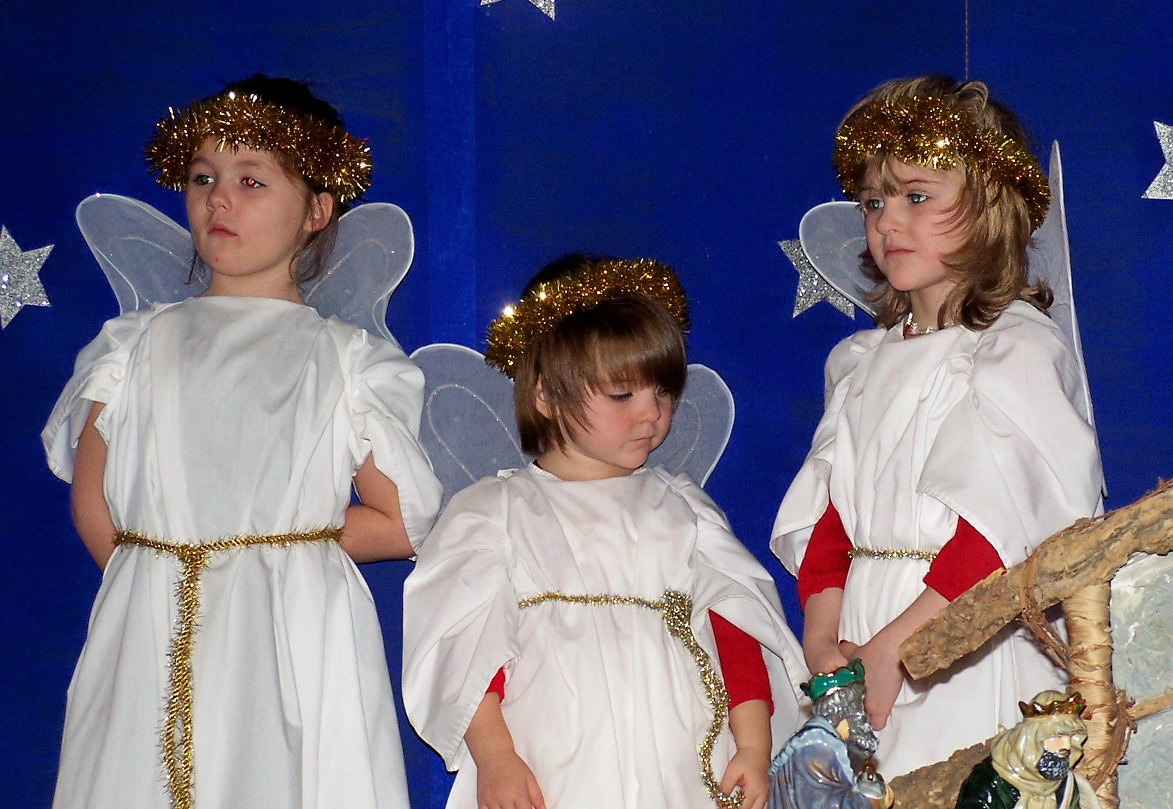

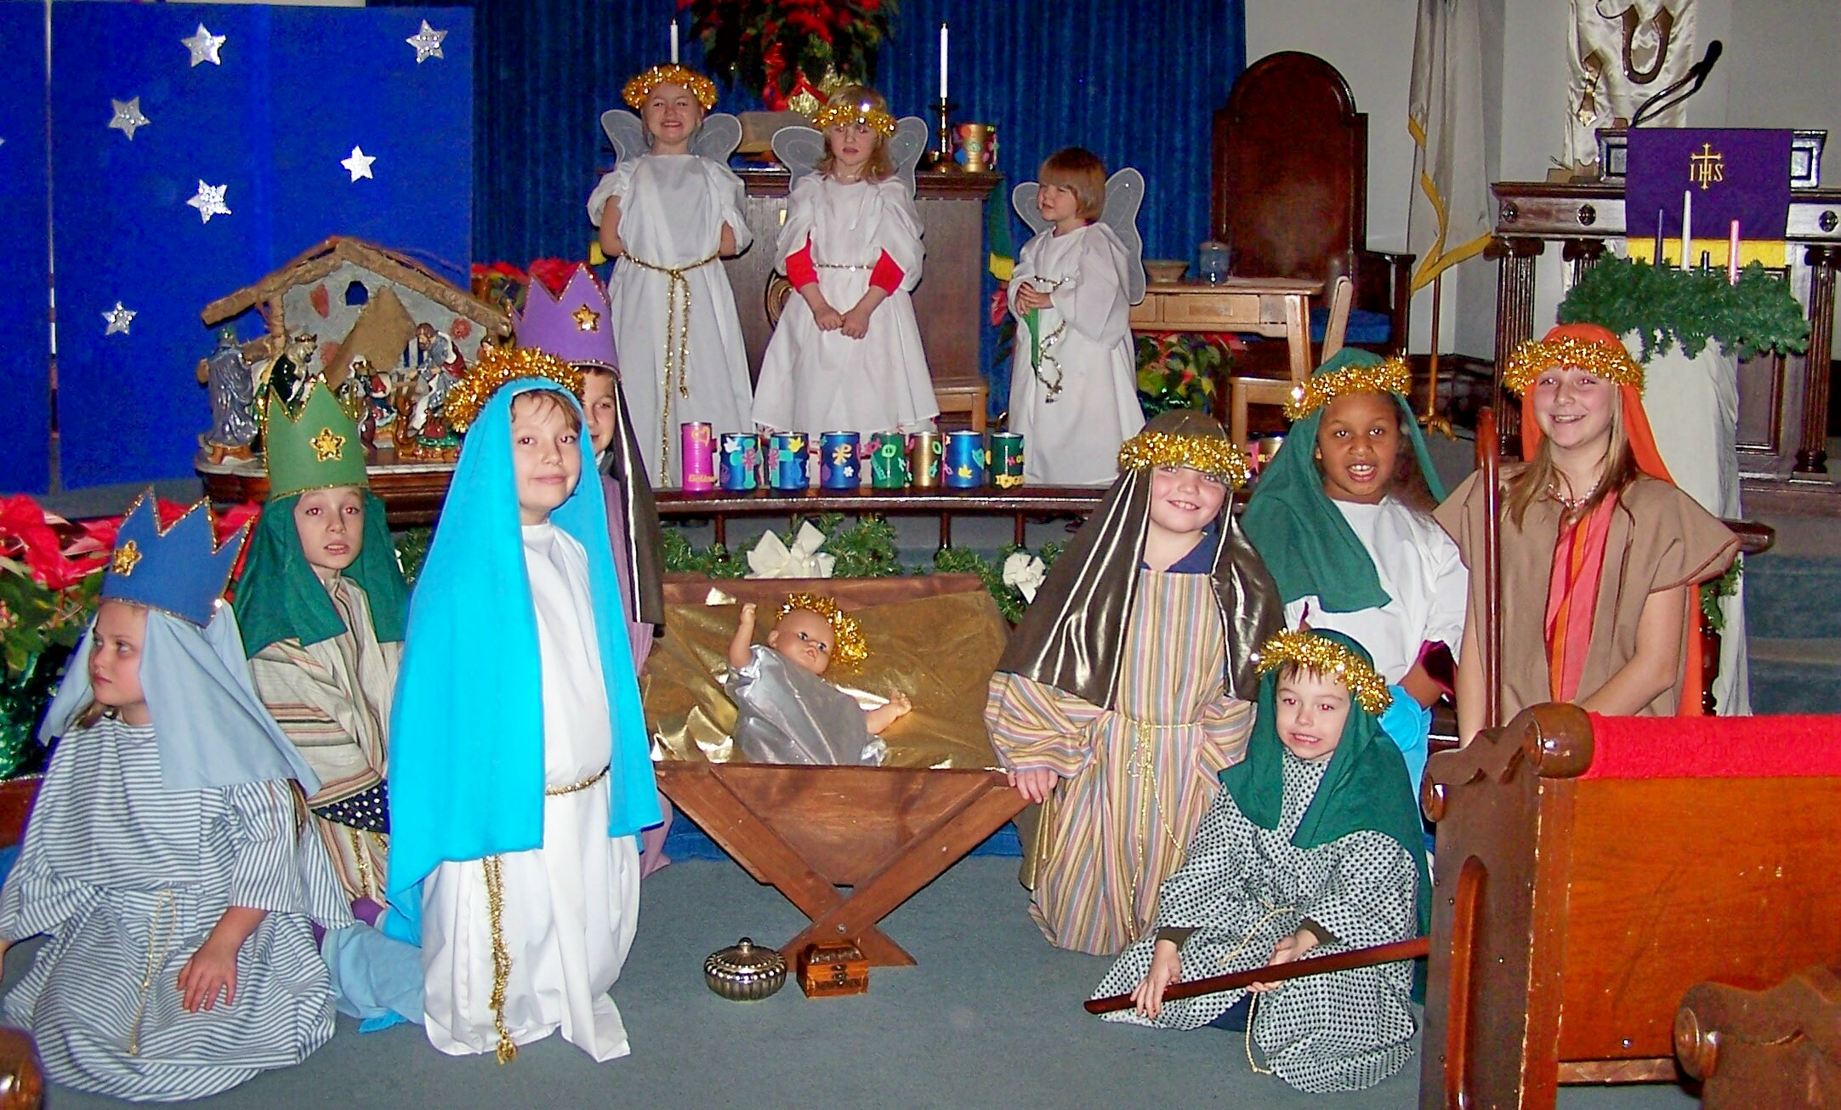
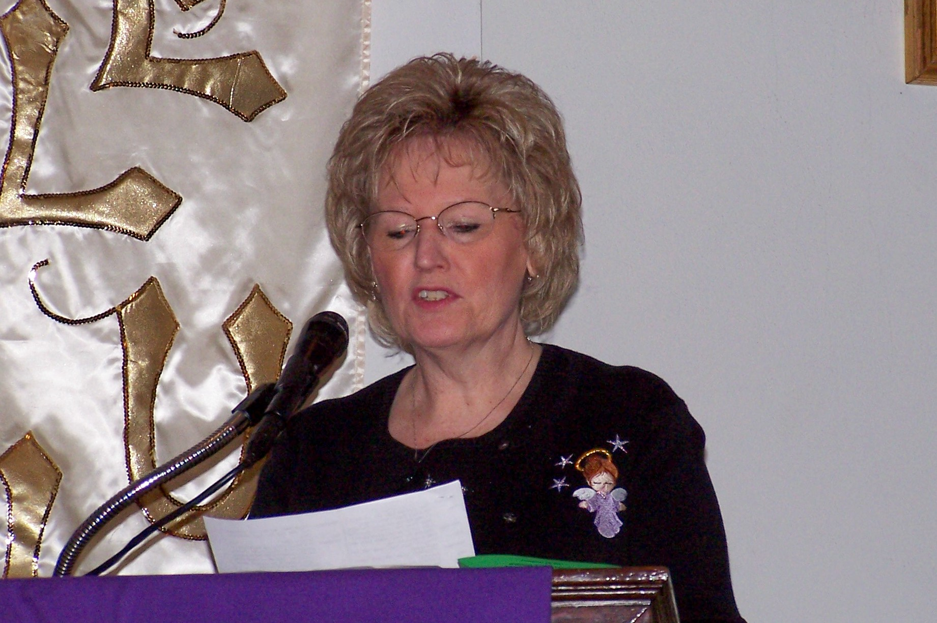

"Heart People"
The Heart Children was started as an outreach program. We discussed the program at UMW and decided to expand on it. We would like to include all ages. We will be including our shut ins and a few other people mentioned. If you know of anyone that needs a little more of God's love to come into their lives. please give me their name, address, and Birthday, so we can include them on our list. The intention is to send them a card and or small gift on holidays, birthdays, etc to let them know they are thought of, not forgotten, and in our prayers. Please let me know at church, phone 330-889-2146, or e-mail, sew4u12@embarqmail.com. I am getting them ready for the first of the year. Thank-you, Dorothy Cleer

